FRIENDS AND FAMILY TEST
Results for July 2023

Thank you to all the patients who completed a friends and family test survey in July 2023.

1. How likely are you to recommend our practice to family and friends if they needed similar care or treatment?
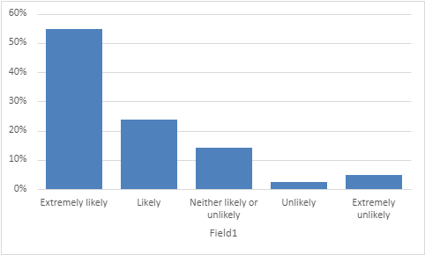
55% are extremely likely to recommend the practice
24% are likely to recommend the practice
14% are neither likely nor unlikely to recommend the practice
2% are unlikely to recommend the practice
5% are extremely unlikely to recommend the practice

2. If we could change one thing about your care or treatment, what would it be?
- Reception staff are so lovely and always polite and very kind.
- Doctor Brown is a thorough and caring doctor.
- Dr Hart has been very thorough and really listened to me.
- Nothing. You were awesome.
- I’m totally happy with my consultations and treatment.
- Always been very impressed. I think patients are very lucky to have such a dedicated and proactive team.
- A very, very good surgery. Always treated with respect.
- Seen quickly and efficiently.
- More face-to-face appointments. Find it difficult to get a face-to-face appointment.
- Having a nurse and GP who are knowledgeable about perimenopause/menopause.
- Much shorter waiting times for appointments.
- Mental Health doctor.
- Feel that sometimes some staff members can be rude.

